Streams Assignment

1. Create the following classes:

Class Fruit{String name; int calories; int price; string colour;}

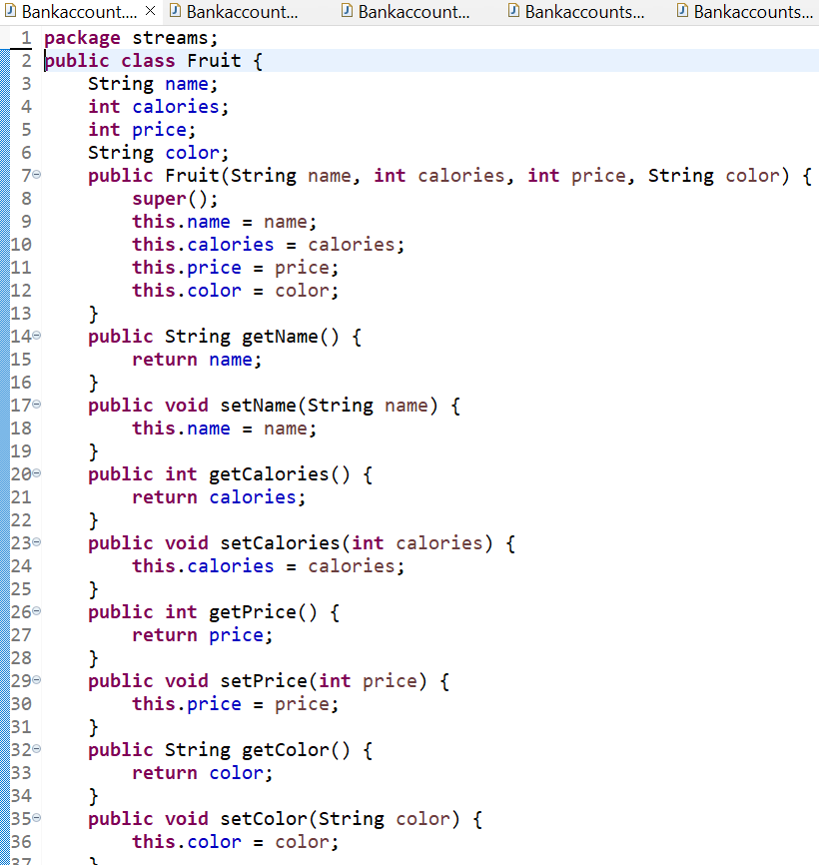

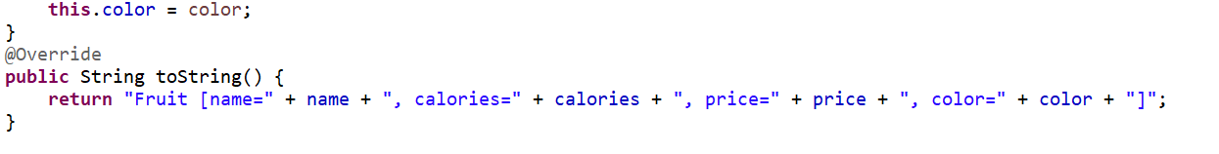

1. Class News {int news Id; String posted By User; String comment By User; String comment;}

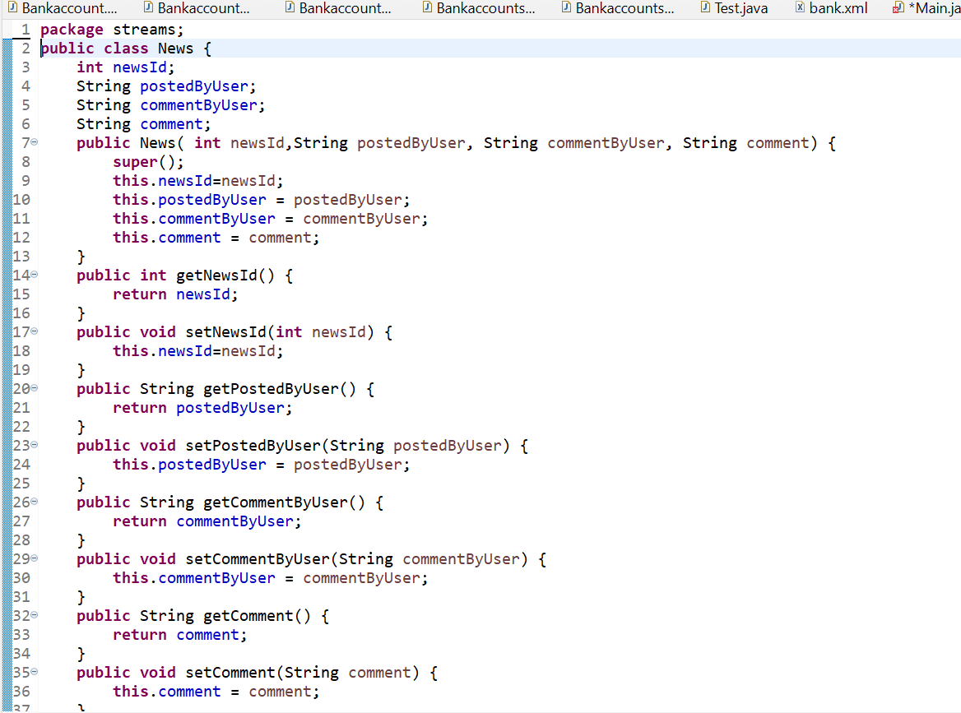



3) Class Trader {String name; String city;}

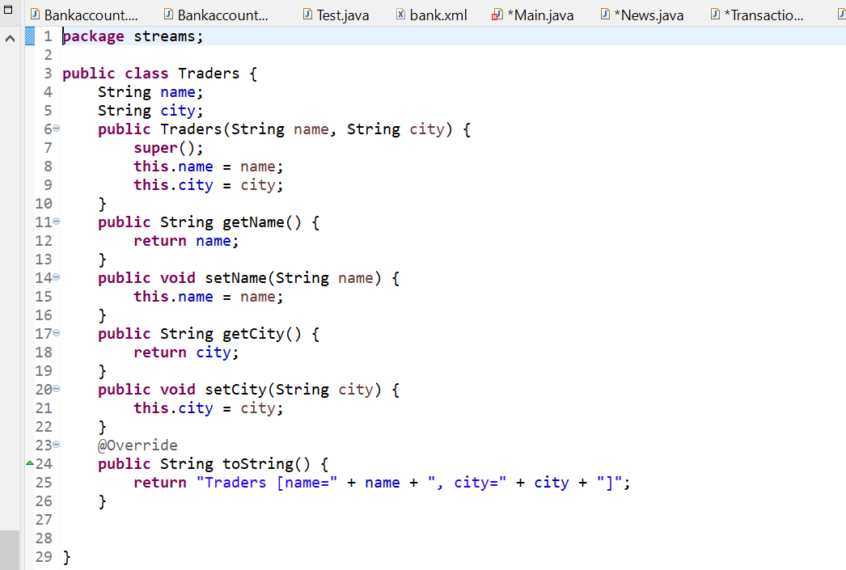

Class Transaction {Trader trader; int year; int value;}

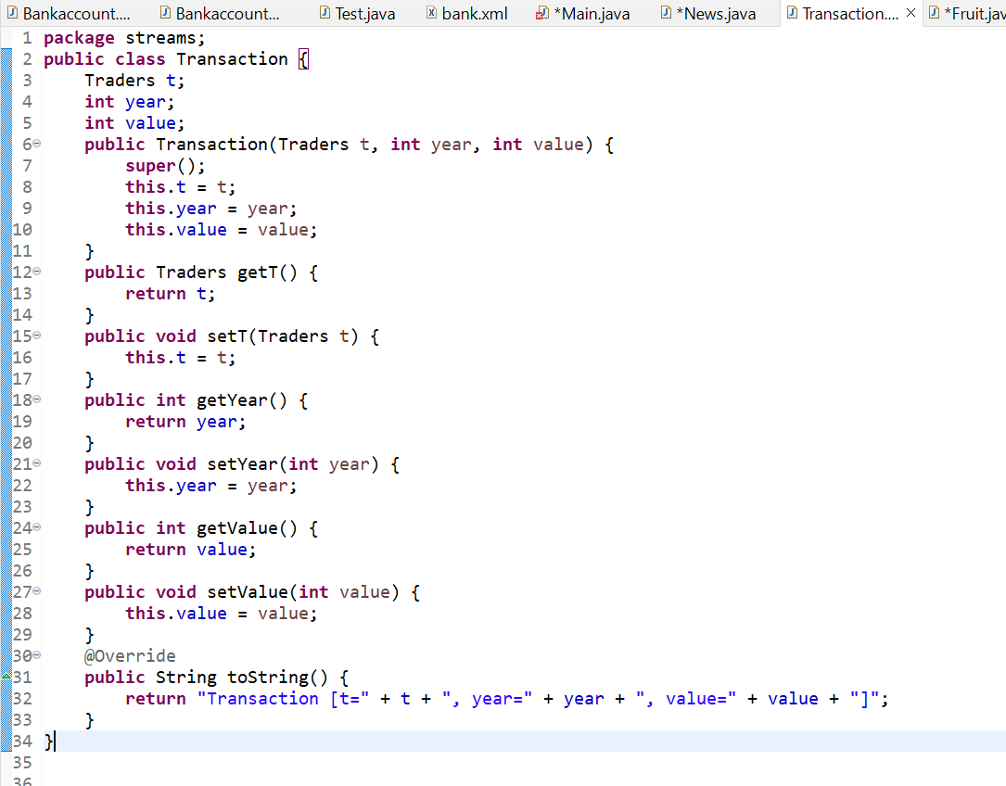

Main.java:

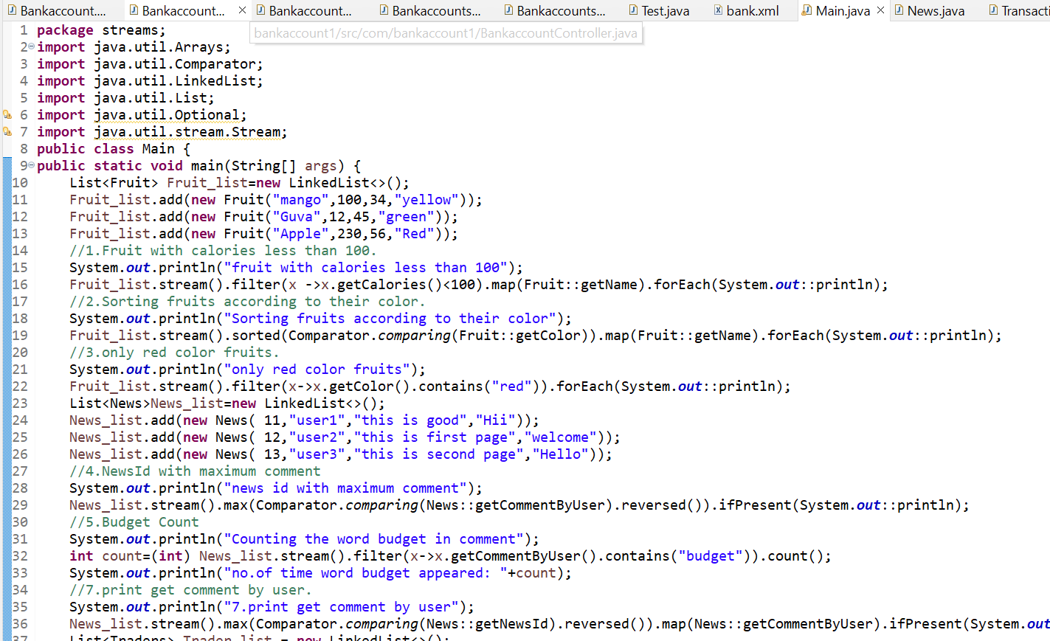

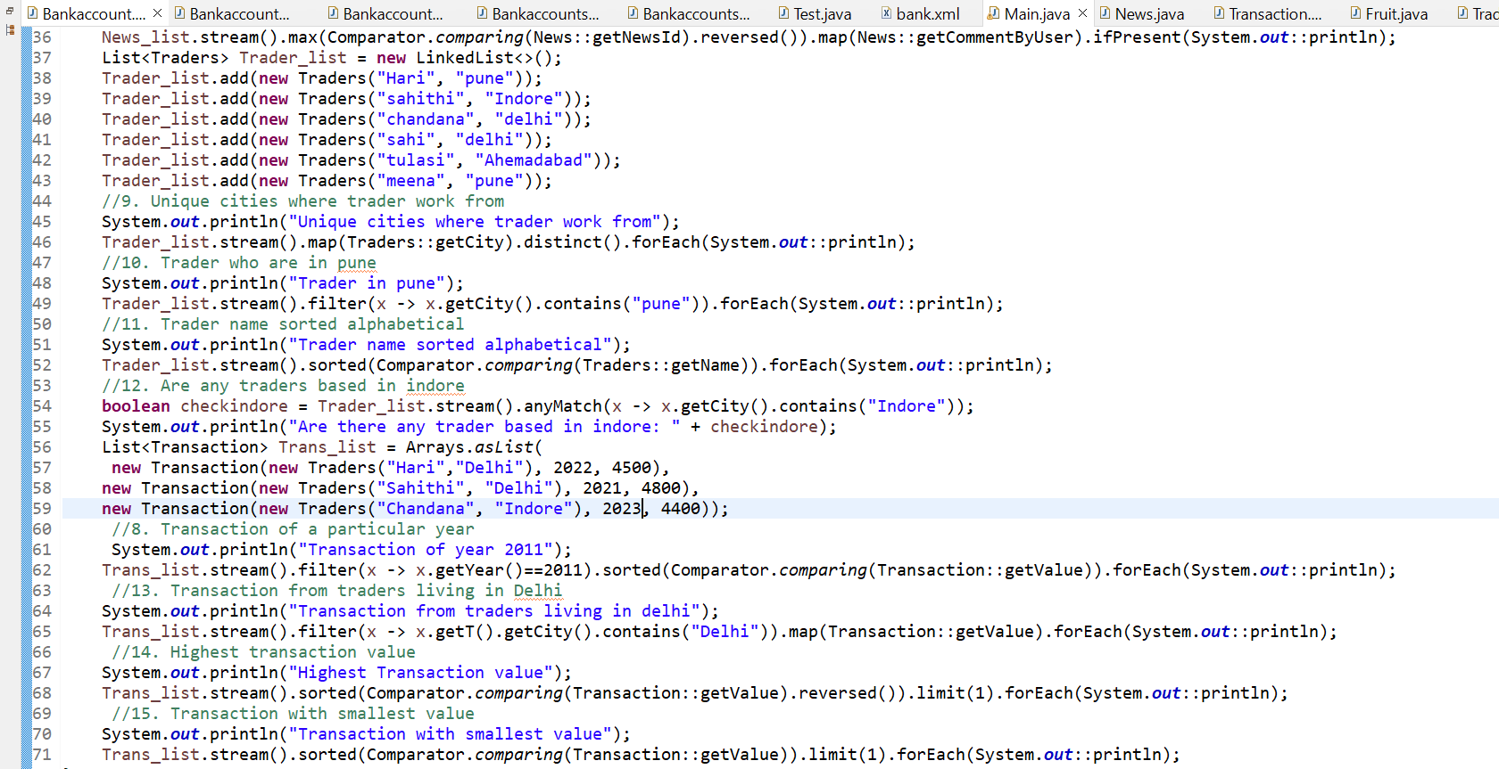

Output:

